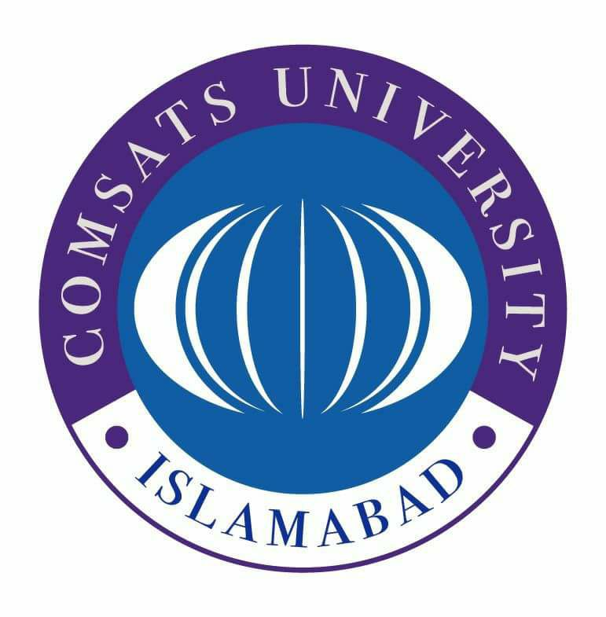
COMSATS University, Islamabad
Sahiwal campus
Works Department
COMSATS Road, Off G.T.Road, Sahiwal
Tel: 040-4305004 Web: www.ciitsahiwal.edu.pk

No. COMSATS/SWL/WD/939 Dated: February01, 2021
OFFICE NOTE:

NOTICE INVITING QUOTATION
Sealed quotations are invited by the undersigned on 04.02.2021 at 1:00 PM for the following work from the Contractors/vendors. The quotations will be opened at 2:00 PM on the same day in the presence of those vendors who may wish to attend. COMSATS University, Islamabad Sahiwal Campus reserves all the rights to reject all quotations at any time prior to the acceptance of quotations. CUI Sahiwal will communicate the grounds for rejection of quotations upon request of any supplier or contractor but not liable to justify those grounds.
Sr.No | Name of work/Description | Quantity | Unit | Rate (Rs.) | Amount (Rs.)
1. | Preparing surface and painting with Plastic Emulsion Paint (ICI, or Equal) including preparation of surface application of Base complete in all respects : old Surface 3 coats & Windows, doors enamel paint G.F Hall F.F Hall Ablution Area, Washroom Complete Mosque (Rate without Taxes) | L.Sum | P-Sft
2. | Providing and Applying weather shield paint of approved quality( ICI or Equal) on external surface of building including preparation of surface application of primer complete in all respects : Old Surface 3 coats(Rate without Taxes) | L.Sum | P-Sft

___________________
Muhammad Amir Raza Secretary (QOC)
CUI, Sahiwal Campus
Cc:
- Director, CUI, Sahiwal Campus
- Incharge CU-online for publishing on the website.

